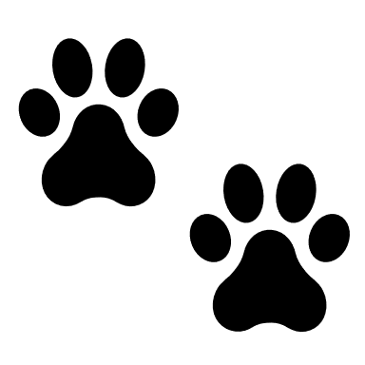 Date: _______/_________/______________
This puppy is guaranteed to be in good health to the best of my knowledge at the time of the sale. This puppy will be examined by my vet to be in good health and if not, deposit will be refunded, or you may choose another puppy. You have 72 hours to have your puppy examined by the vet of your choice at buyer's expense or this contract is void. All deposits are non-refundable unless puppy becomes unhealthy while in my care. In this event, deposit will be refunded, but if the buyer backs out of the adoption or the puppy is not picked up by the date agreed upon, deposit is not refunded. If your vet finds anything to be genetically life threatening wrong with the puppy, the seller will then replace the puppy with one of equal value after a full report is provided to me from buyer’s vet and verified by the breeder’s vet of choice. Report must be leader headed from your vet and have a signature from your vet. If you visit multiple veterinarians for any reason a report will be required and verified from each. In the event that your vet does not know the cause of death, a necropsy is required at the buyers’ expense to provide cause of death. This information must be faxed/emailed to the breeder and vet of breeders’ choice for review within 72 hours of death.
Buyer understands that puppy needs at least a two-week adjustment period to its new home and people. Puppy needs to be continued on the food that was provided by the breeder. If you decide to change the food, you understand that it can upset the stomach. Please read the print off on hypoglycemia provided by me in your bag. This can happen in any small breed puppy. Have nutrical on hand (provided by me, the breeder) or clear kayro syrup. Puppy will need to be feed every 3 to 4 hours. until at least 4 months old.
I do not guarantee color, coat, adult size, weight, temperament, or reproductive ability of this puppy, nor does it cover common conditions such as, but not limited to: Hypoglycemia — which is low blood sugar, hernia, improper bite, cherry eye, allergies. The defects do not include minor illness such as: coccidia, fleas, mites, intestinal parasites, bacteria or yeast. All puppies have a fecal done at my vet and if any parasites are found, puppy will be treated by my vet prior to leaving. This is common in puppies.
Parvo is a very contagious deadly disease known in dogs and puppies. First vaccinations are given at my vet. Buyer is responsible for giving the rest of the series of shots for protection on time by a vet. Puppies should not be placed on strange ground, such as dog parks, etc., until after their third set of shots. As per my vet, they are not completely protected until after the entire series of puppy shots for parvo protection have been given. Only then it is safe to place the puppy into public places and expect them to be safe.
If for some reason you are no longer able to care for the puppy or dog, please do contact me. Do not place puppy in a shelter, rescue, or pound. You will have to continue veterinary care for this puppy as I have provided proper care and ask that you do the same. By signing you agree to the contents of this contract and are now the proud owner of a beautiful Yorkie!
Buyer/Owner Signature: _______________________________________________________
Breeder/Seller Signature: _______________________________________________________

